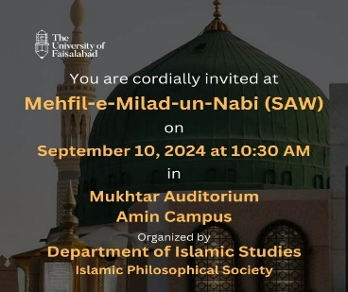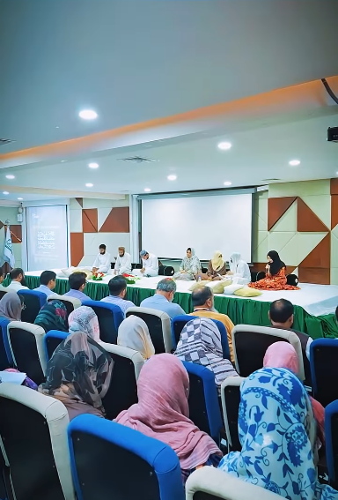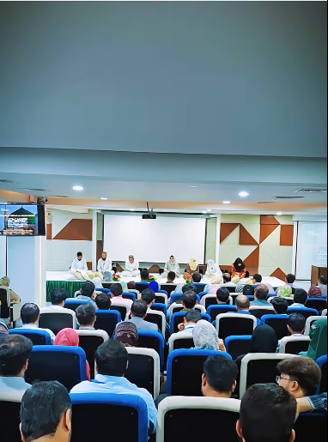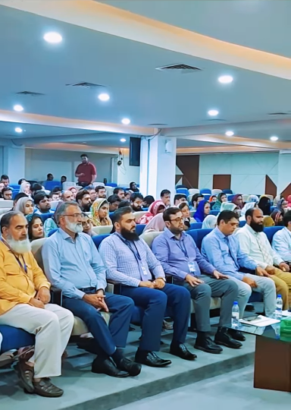
Event Report: Milad in Celebration of New Faculty Orientation at The University of Faisalabad
On 10th September 2024, "The University of Faisalabad" hosted a memorable Milad event to celebrate the orientation of newly hired faculty members. The event was beautifully aligned with the spiritual significance of 12th Rabi ul Awwal, the birth anniversary of the Holy Prophet Muhammad (PBUH). It was an inspiring gathering that brought together faculty, students, and staff to commemorate this special occasion with devotion and unity.
The event commenced with a soulful recitation of the Holy Quran by Abu Bakar, setting a serene and blessed tone for the gathering. The atmosphere was filled with spirituality and love as students recited heartfelt Naats, paying tribute to the Prophet Muhammad (PBUH). Among the Naat reciters were Usman, Baleeha, Urooj, Hamna, and Saba, whose melodious voices captivated the audience and spread an aura of peace and devotion.
Organized by the Department of Islamic Studies and meticulously managed by the Islamic Philosophic Society, the Milad was a meaningful opportunity for the university community to come together and reflect on the values of compassion, knowledge, and respect that the Prophet (PBUH) exemplified. The Islamic Philosophic Society's efforts ensured that the event ran smoothly and maintained its spiritual essence throughout.
The Milad event was a beautiful blend of tradition and reflection, fostering a sense of community among the new faculty members and the university at large. It served as a reminder of the timeless teachings of the Holy Prophet Muhammad (PBUH) and their relevance in today’s world, especially in an academic setting like The University of Faisalabad.
We extend our heartfelt appreciation to everyone who participated and contributed to making this event a success. May the spirit of unity, knowledge, and faith continue to thrive at our university.

